Mercury Thermometer
# Source: AI Source: Provided by: [Data Path: Persons Table -> ID Column: 1, Name_En Column: Motasem Essam] -> From: [ChatGPT] on [7/17/2026]
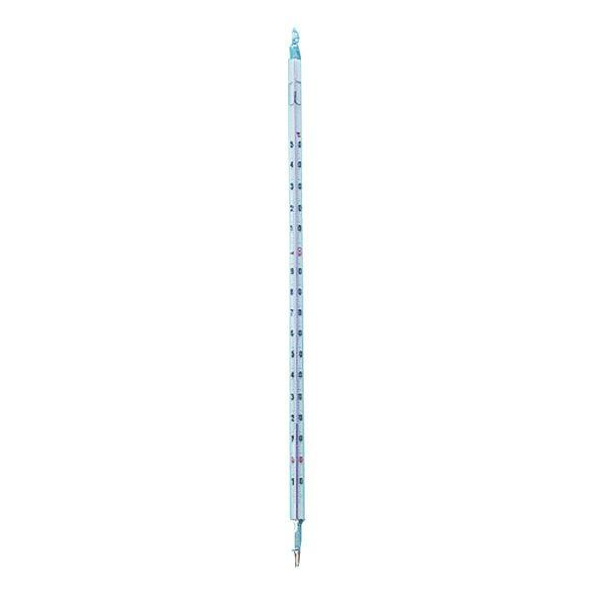
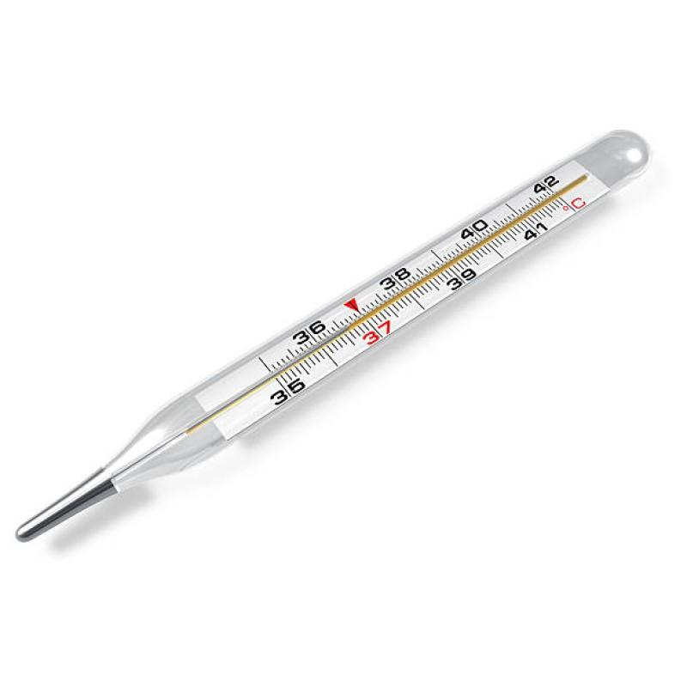
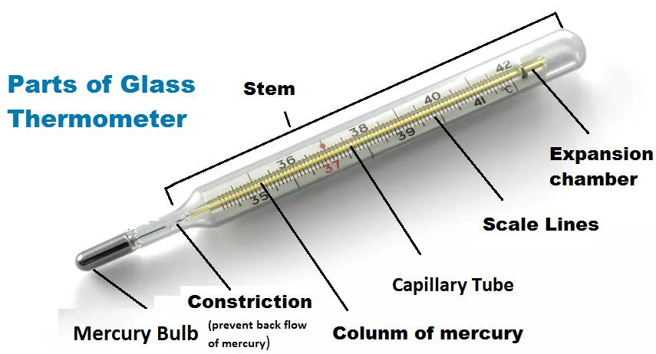
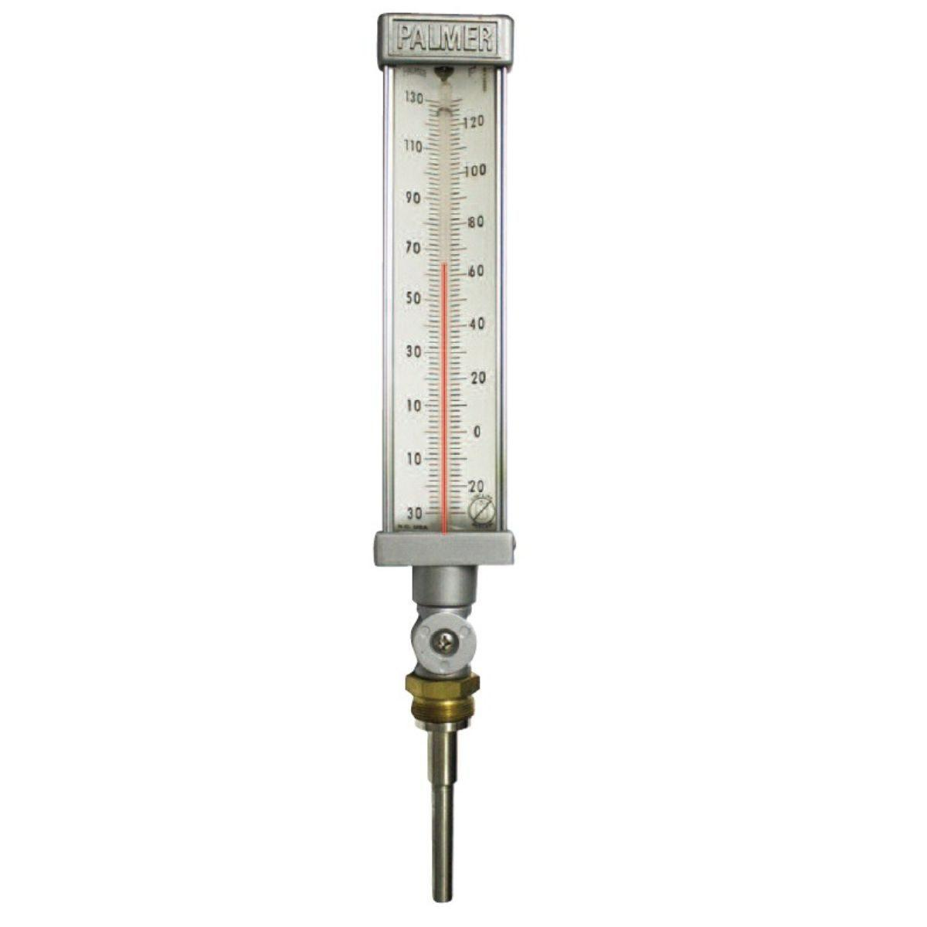
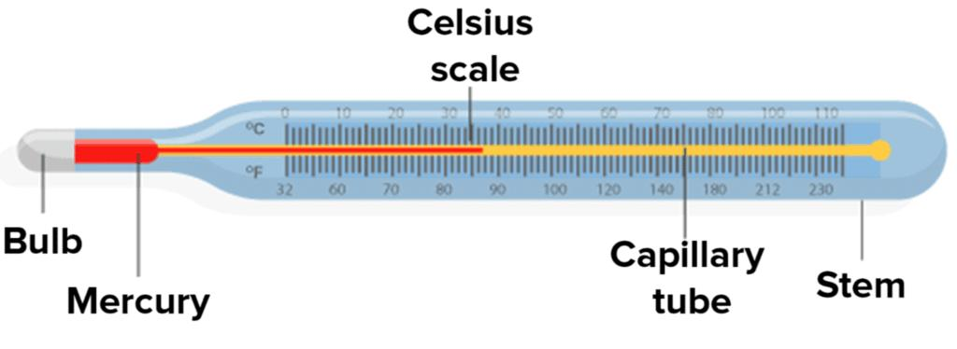
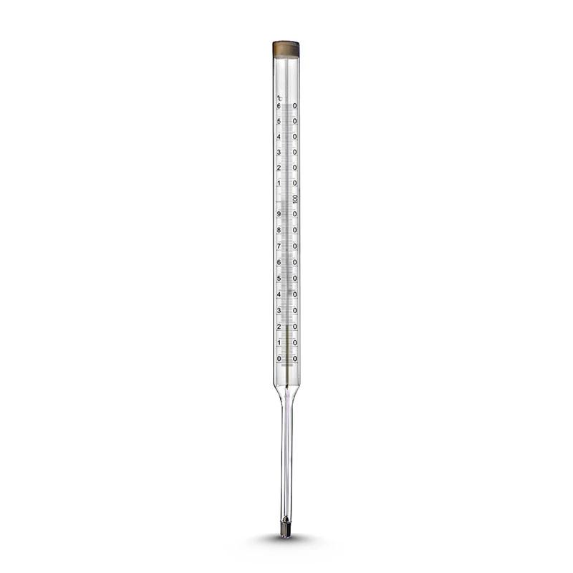
A Mercury Thermometer is a temperature-measuring instrument that uses mercury (Hg) enclosed inside a sealed glass tube. As temperature increases, the mercury expands and rises in the narrow capillary tube; as temperature decreases, it contracts and falls. The height of the mercury column indicates the temperature on a calibrated scale.
For many years, mercury thermometers were widely used in laboratories, medicine, meteorology, and industry. Today, their use has declined because mercury is toxic, and many countries have replaced them with digital, alcohol, or infrared thermometers.

Definition
# Source: AI Source: Provided by: [Data Path: Persons Table -> ID Column: 1, Name_En Column: Motasem Essam] -> From: [ChatGPT] on [7/17/2026]
A Mercury Thermometer is a liquid-in-glass thermometer that measures temperature by the thermal expansion and contraction of mercury within a sealed glass capillary tube.

Purpose
# Source: AI Source: Provided by: [Data Path: Persons Table -> ID Column: 1, Name_En Column: Motasem Essam] -> From: [ChatGPT] on [7/17/2026]
A mercury thermometer is used to:
- Measure air temperature.
- Measure liquid temperature.
- Measure body temperature (clinical models).
- Monitor laboratory experiments.
- Measure industrial process temperatures.
- Calibrate other thermometers.

Principle of Operation
# Source: AI Source: Provided by: [Data Path: Persons Table -> ID Column: 1, Name_En Column: Motasem Essam] -> From: [ChatGPT] on [7/17/2026]
Mercury expands when heated and contracts when cooled.
As temperature changes:
- Higher temperature → mercury expands → column rises.
- Lower temperature → mercury contracts → column falls.
The level of the mercury column is read against a calibrated scale.

Main Components
# Source: AI Source: Provided by: [Data Path: Persons Table -> ID Column: 1, Name_En Column: Motasem Essam] -> From: [ChatGPT] on [7/17/2026]
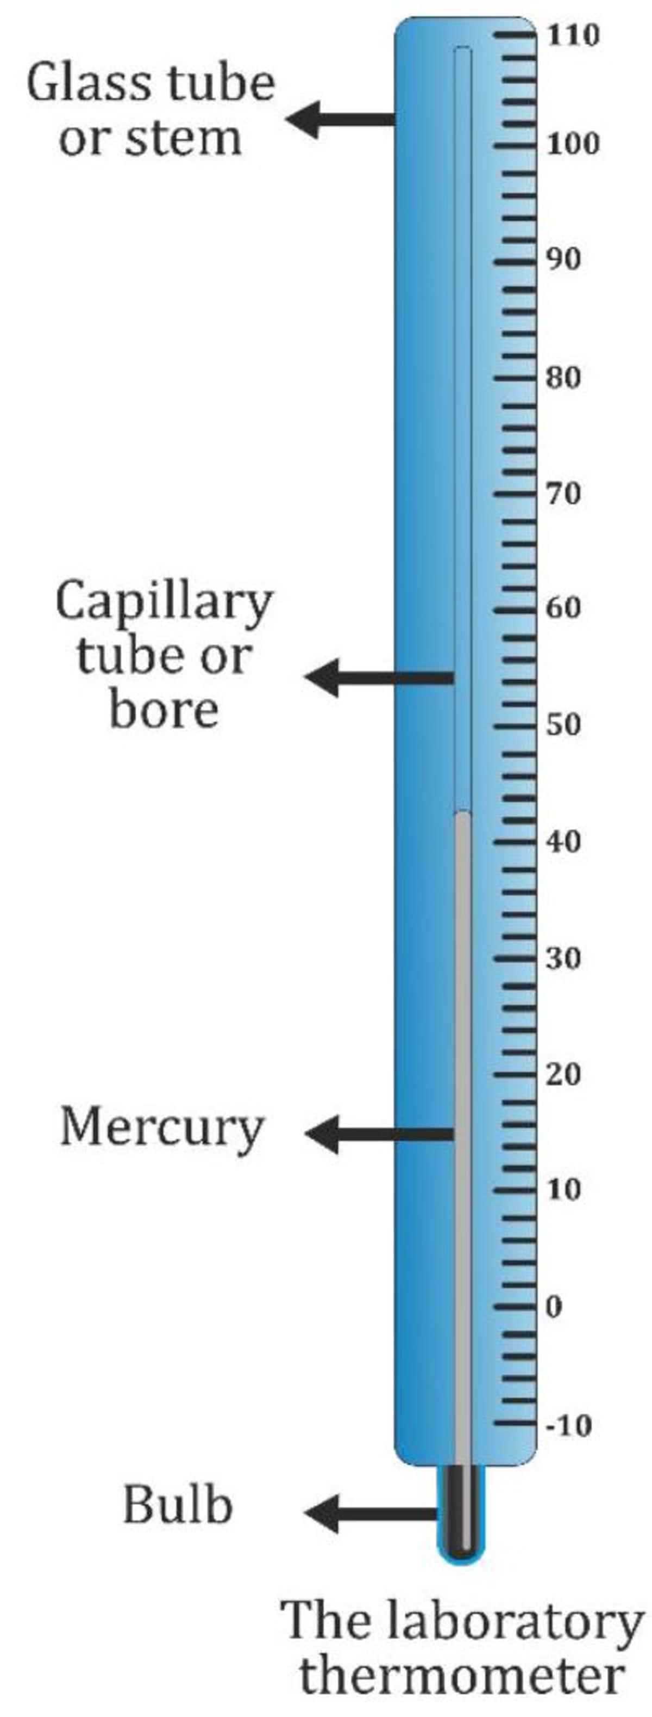

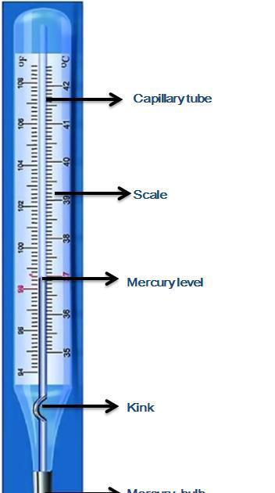
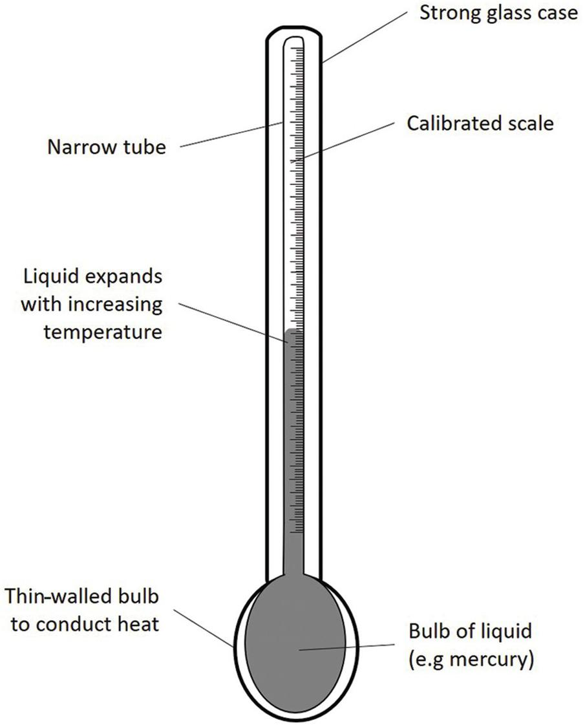
A mercury thermometer typically consists of:
- Mercury bulb (reservoir)
- Mercury column
- Glass capillary tube
- Graduated temperature scale
- Glass stem
- Expansion chamber (in many laboratory models)

Types of Mercury Thermometers

1. Clinical Mercury Thermometer
# Source: AI Source: Provided by: [Data Path: Persons Table -> ID Column: 1, Name_En Column: Motasem Essam] -> From: [ChatGPT] on [7/17/2026]
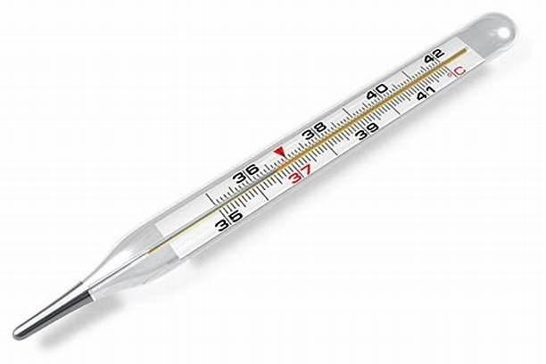
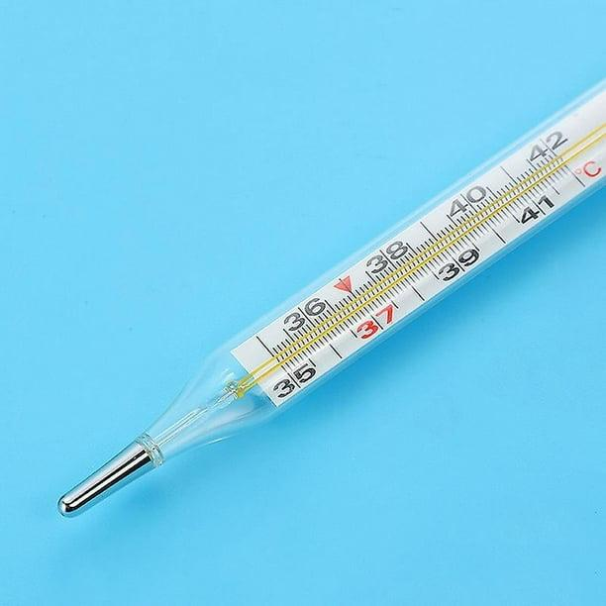
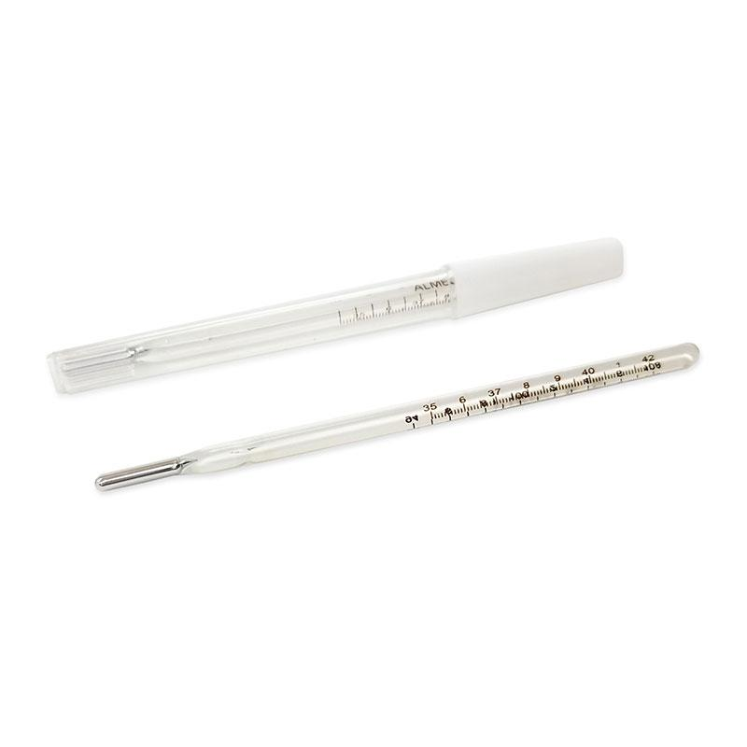
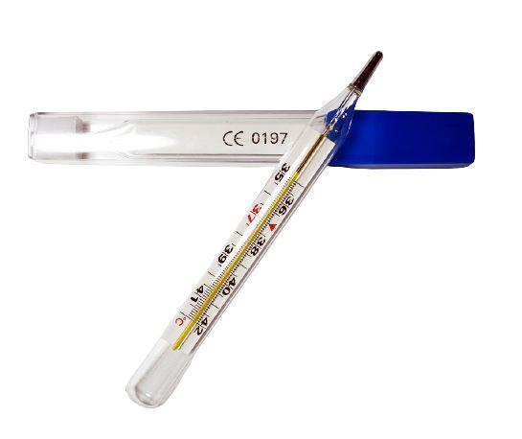
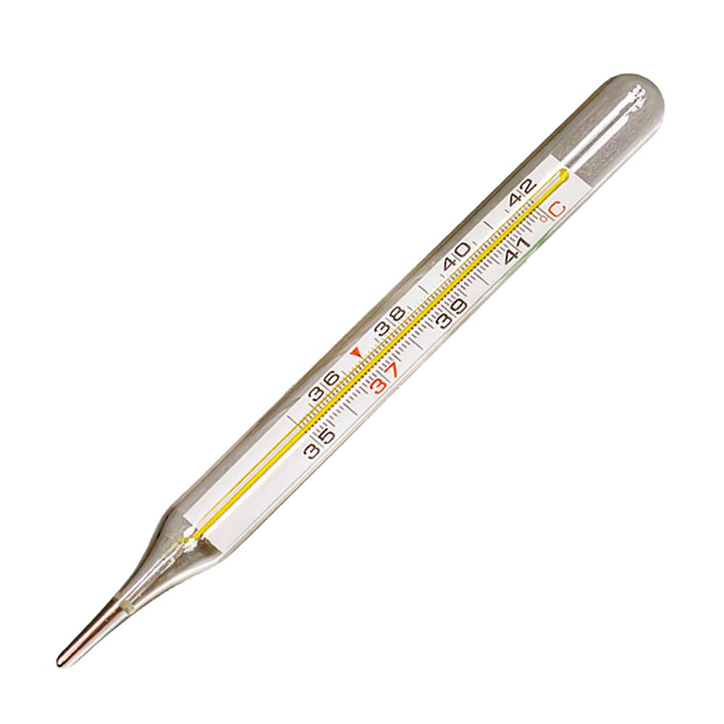
Description:
- Designed specifically for measuring human body temperature.
- Has a constriction (kink) near the bulb that prevents the mercury from falling immediately after measurement, allowing the reading to be observed until the thermometer is shaken down.
Typical Range:
- 35°C to 42°C
Applications:
- Medical examinations (historically)
- Hospitals and clinics (before digital thermometers became common)

2. Laboratory Mercury Thermometer
# Source: AI Source: Provided by: [Data Path: Persons Table -> ID Column: 1, Name_En Column: Motasem Essam] -> From: [ChatGPT] on [7/17/2026]

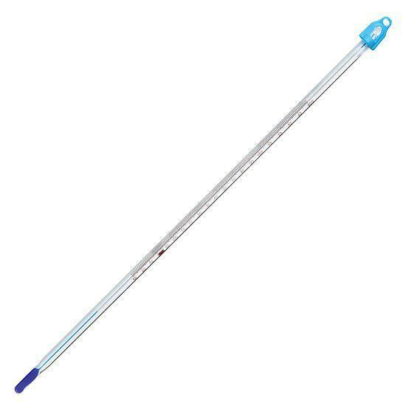
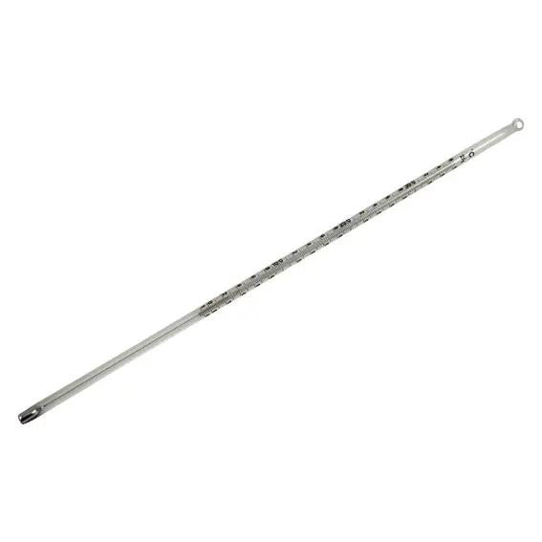
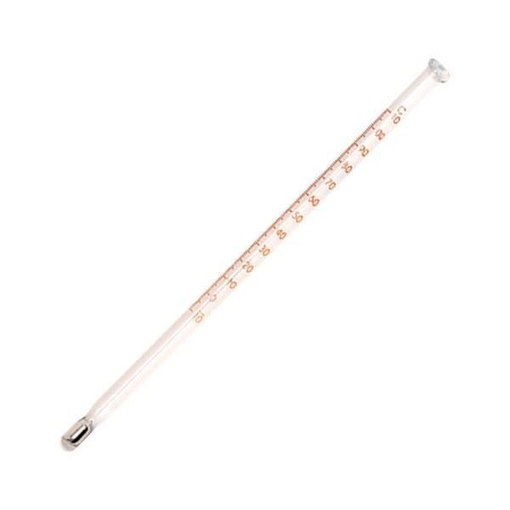
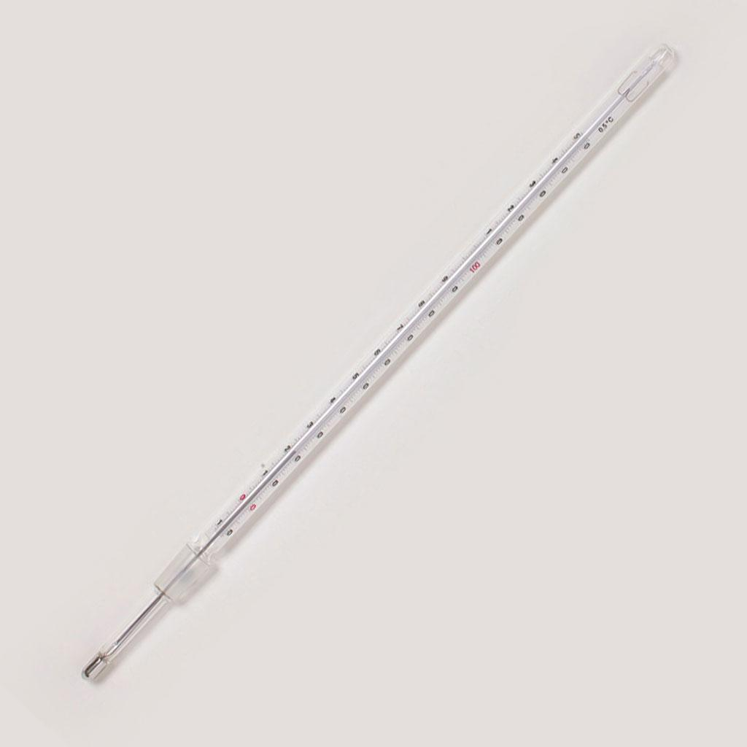
Description:
- Used for measuring temperatures in scientific experiments.
- Does not have a constriction, allowing the mercury to move freely with temperature changes.
- Available in many temperature ranges depending on the application.
Typical Range:
- Commonly −10°C to 110°C, though specialized models cover much wider ranges.
Applications:
- Chemistry laboratories
- Physics laboratories
- Biology laboratories
- Educational laboratories

3. Industrial Mercury Thermometer
# Source: AI Source: Provided by: [Data Path: Persons Table -> ID Column: 1, Name_En Column: Motasem Essam] -> From: [ChatGPT] on [7/17/2026]
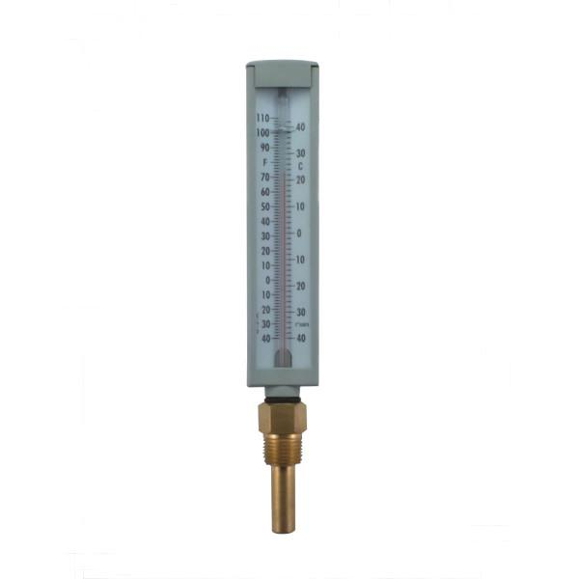

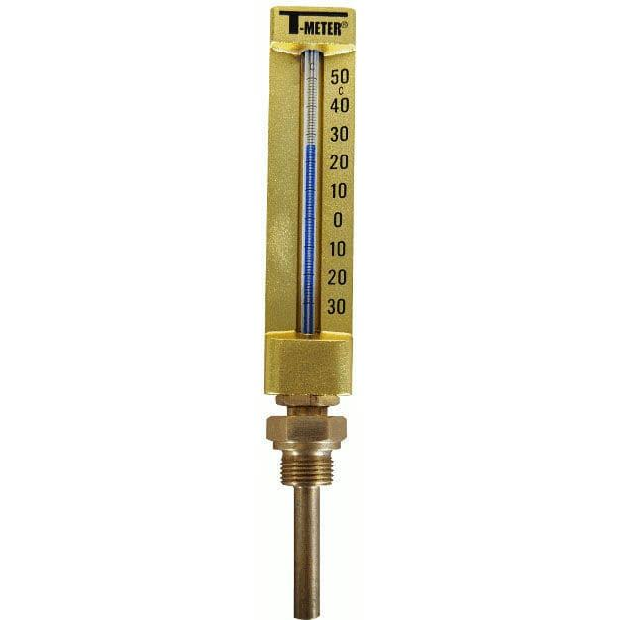
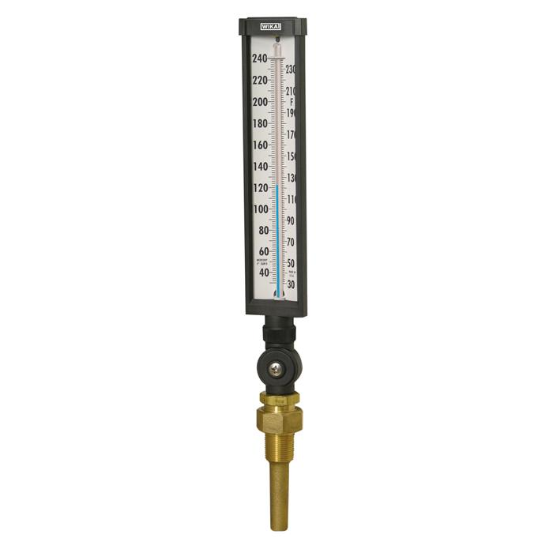
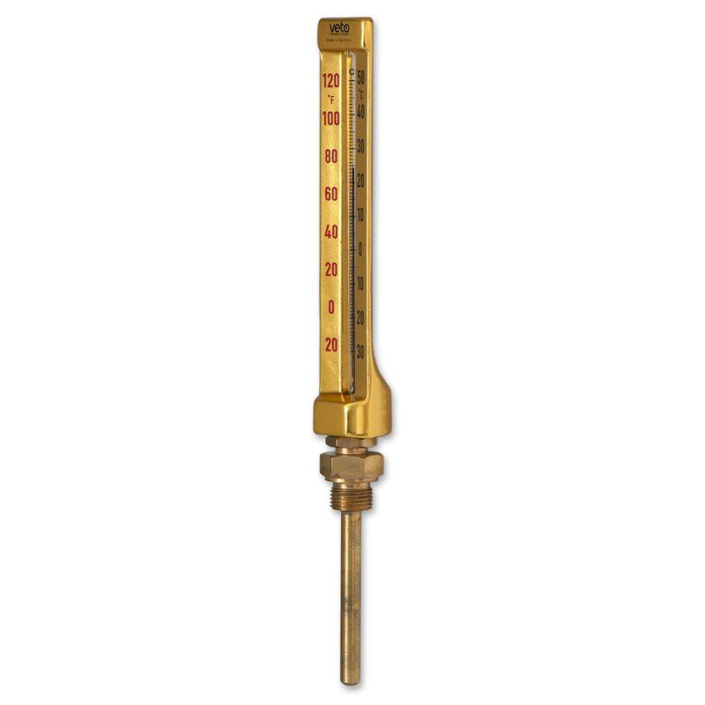
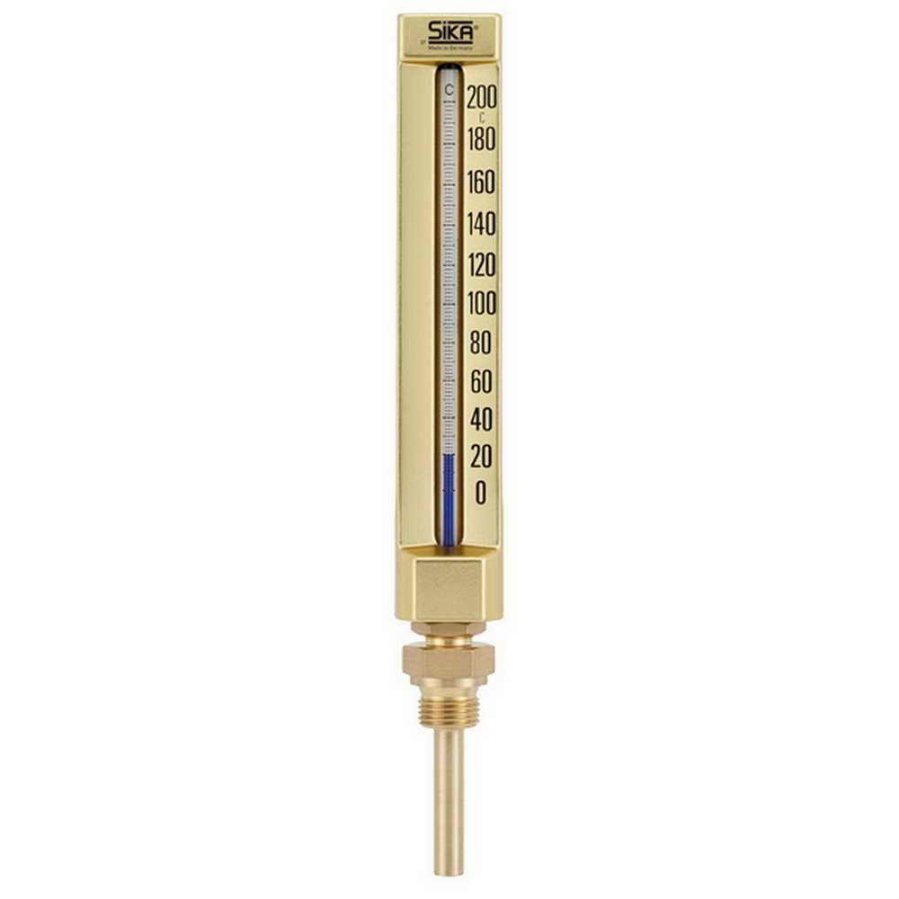
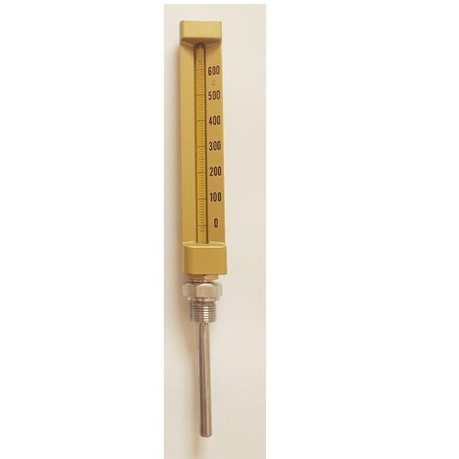
Description:
- Built for industrial process monitoring and harsh environments.
- Often features a reinforced glass stem, protective metal casing, or threaded fittings for installation in tanks, pipes, boilers, and machinery.
Typical Range:
- Varies widely depending on the model, from below −30°C to several hundred °C.
Applications:
- Chemical plants
- Manufacturing processes
- Boilers and steam systems
- Storage tanks
- Industrial equipment monitoring

Measuring Units
# Source: AI Source: Provided by: [Data Path: Persons Table -> ID Column: 1, Name_En Column: Motasem Essam] -> From: [ChatGPT] on [7/17/2026]
Mercury thermometers may be calibrated in:
- Degrees Celsius (°C)
- Degrees Fahrenheit (°F)
- Kelvin (K) (laboratory applications, less common)

Measuring Range
# Source: AI Source: Provided by: [Data Path: Persons Table -> ID Column: 1, Name_En Column: Motasem Essam] -> From: [ChatGPT] on [7/17/2026]
Typical ranges include:
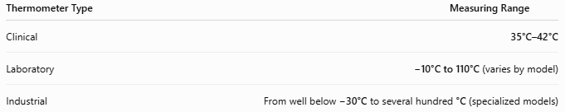
Thermometer Type | Measuring Range
Clinical | 35°C–42°C
Laboratory | −10°C to 110°C (varies by model)
Industrial | From well below −30°C to several hundred °C (specialized models)

Resolution
# Source: AI Source: Provided by: [Data Path: Persons Table -> ID Column: 1, Name_En Column: Motasem Essam] -> From: [ChatGPT] on [7/17/2026]
Typical resolution:
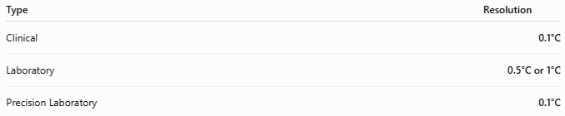
Type | Resolution
Clinical | 0.1°C
Laboratory | 0.5°C or 1°C
Precision Laboratory | 0.1°C

Accuracy
# Source: AI Source: Provided by: [Data Path: Persons Table -> ID Column: 1, Name_En Column: Motasem Essam] -> From: [ChatGPT] on [7/17/2026]
Typical accuracy:
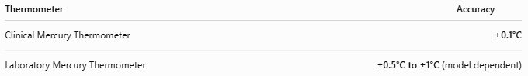
Thermometer | Accuracy
Clinical Mercury Thermometer | ±0.1°C
Laboratory Mercury Thermometer | ±0.5°C to ±1°C (model dependent)

How to Use a Mercury Thermometer
# Source: AI Source: Provided by: [Data Path: Persons Table -> ID Column: 1, Name_En Column: Motasem Essam] -> From: [ChatGPT] on [7/17/2026]
- Ensure the mercury column is below the starting temperature (shake down a clinical thermometer if needed).
- Place the bulb in contact with the object or substance being measured.
- Wait until the reading stabilizes.
- Hold the thermometer at eye level.
- Read the top of the mercury column against the scale.
- Remove and clean the thermometer if appropriate.

Example
# Source: AI Source: Provided by: [Data Path: Persons Table -> ID Column: 1, Name_En Column: Motasem Essam] -> From: [ChatGPT] on [7/17/2026]
A laboratory thermometer shows the mercury column at:
27°C
Measured temperature:
27°C

Applications
# Source: AI Source: Provided by: [Data Path: Persons Table -> ID Column: 1, Name_En Column: Motasem Essam] -> From: [ChatGPT] on [7/17/2026]
Mercury thermometers are used (or were historically used) in:
- Scientific laboratories
- Medical clinics
- Hospitals
- Weather stations
- Industrial process monitoring
- Schools
- Calibration laboratories

Advantages
# Source: AI Source: Provided by: [Data Path: Persons Table -> ID Column: 1, Name_En Column: Motasem Essam] -> From: [ChatGPT] on [7/17/2026]
A mercury thermometer:
- Provides stable and accurate readings.
- Does not require batteries.
- Has a long service life when handled properly.
- Offers good visibility of the mercury column.
- Performs well over a wide temperature range.

Limitations
# Source: AI Source: Provided by: [Data Path: Persons Table -> ID Column: 1, Name_En Column: Motasem Essam] -> From: [ChatGPT] on [7/17/2026]
A mercury thermometer:
- Contains toxic mercury.
- Can break easily because it is made of glass.
- Is slower than many digital thermometers.
- Requires careful disposal if broken.
- Has been restricted or banned in many countries for routine use due to environmental and health concerns.

Safety Precautions
# Source: AI Source: Provided by: [Data Path: Persons Table -> ID Column: 1, Name_En Column: Motasem Essam] -> From: [ChatGPT] on [7/17/2026]
⚠ Mercury is hazardous.
If a mercury thermometer breaks:
- Do not touch the mercury with bare hands.
- Do not use a vacuum cleaner.
- Ventilate the area.
- Collect mercury beads using appropriate tools and follow local hazardous waste disposal guidelines.
- Keep children and pets away from the spill.

Sources of Error
# Source: AI Source: Provided by: [Data Path: Persons Table -> ID Column: 1, Name_En Column: Motasem Essam] -> From: [ChatGPT] on [7/17/2026]
Instrument Errors
- Damaged or cracked glass
- Separated mercury column
- Calibration error

User Errors
- Reading from an incorrect angle (parallax)
- Not waiting for temperature stabilization
- Incomplete contact between the bulb and the object

Environmental Errors
- Rapid temperature changes
- Direct sunlight during air temperature measurements
- Heat transfer from the user's hand to the thermometer stem

Comparison with Other Temperature Measuring Instruments
# Source: AI Source: Provided by: [Data Path: Persons Table -> ID Column: 1, Name_En Column: Motasem Essam] -> From: [ChatGPT] on [7/17/2026]
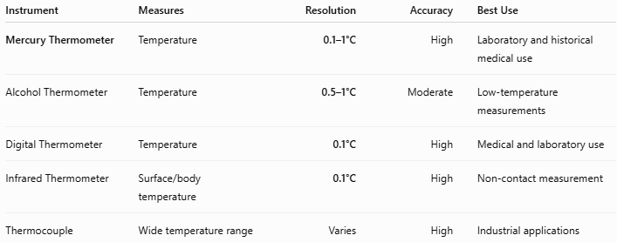
Instrument | Measures | Resolution | Accuracy | Best Use
Mercury Thermometer | Temperature | 0.1–1°C | High | Laboratory and historical medical use
Alcohol Thermometer | Temperature | 0.5–1°C | Moderate | Low-temperature measurements
Digital Thermometer | Temperature | 0.1°C | High | Medical and laboratory use
Infrared Thermometer | Surface/body temperature | 0.1°C | High | Non-contact measurement
Thermocouple | Wide temperature range | Varies | High | Industrial applications

Care and Maintenance
# Source: AI Source: Provided by: [Data Path: Persons Table -> ID Column: 1, Name_En Column: Motasem Essam] -> From: [ChatGPT] on [7/17/2026]
To maintain accuracy:
- Store in a protective case.
- Avoid impacts and dropping.
- Clean after use.
- Keep away from extreme mechanical stress.
- Inspect for cracks before use.

Common Mistakes
# Source: AI Source: Provided by: [Data Path: Persons Table -> ID Column: 1, Name_En Column: Motasem Essam] -> From: [ChatGPT] on [7/17/2026]
- Reading the scale at an angle.
- Holding the thermometer by the bulb during measurement.
- Using a damaged thermometer.
- Not shaking down a clinical thermometer before reuse.
- Using a mercury thermometer where electronic or non-mercury alternatives are required by regulations.

Key Points
# Source: AI Source: Provided by: [Data Path: Persons Table -> ID Column: 1, Name_En Column: Motasem Essam] -> From: [ChatGPT] on [7/17/2026]
- A Mercury Thermometer measures temperature using the thermal expansion of mercury.
- Common types:
  - Clinical Mercury Thermometer
  - Laboratory Mercury Thermometer
  - Industrial Mercury Thermometer
- Common units:
  - °C
  - °F
- Typical accuracy:
  - ±0.1°C (clinical)
- It has largely been replaced by digital and alcohol thermometers because of mercury safety concerns.

Conclusion
# Source: AI Source: Provided by: [Data Path: Persons Table -> ID Column: 1, Name_En Column: Motasem Essam] -> From: [ChatGPT] on [7/17/2026]
A Mercury Thermometer is a classic and highly accurate temperature-measuring instrument that operates by the expansion and contraction of mercury within a sealed glass tube. It has played a vital role in medicine, scientific research, meteorology, and industry for more than a century. Although its use has decreased due to the health and environmental risks associated with mercury, it remains an important instrument in the history of measurement and continues to be encountered in some laboratories and specialized applications.

